1 (a) Write a program in assembly language to print single character on screen.

ORG 100h ; Origin, program starts at 100h (for COM file format)

MOV DX, OFFSET msg ; Load the address of the message into DX

MOV AH, 09h ; Function 09h of INT 21h is used to display a string

INT 21h ; Call DOS interrupt to print the string

MOV DL, 'Z' ; Load the ASCII value of 'X' into DL register

MOV AH, 02h ; Function 02h of INT 21h is used to print a single character

INT 21h ; Call DOS interrupt to print the character

MOV AH, 4Ch ; Function 4Ch of INT 21h to terminate the program

INT 21h ; Call DOS interrupt to exit

msg DB 'The single character is: $' ; Message to print, ending with '$'

END ; End of program

(b) Write an assembly language program to convert an upper-case letter to the

corresponding lower-case letter.

ORG 100h ; Origin, to specify that the program starts at 100h (COM file format)

; Display message "Enter an uppercase letter: "

MOV DX, OFFSET msg_input ; Load the address of the message

MOV AH, 09h ; Function 09h of INT 21h is used to display a string

INT 21h ; Call DOS interrupt to print the message

; Read a single character from the user

MOV AH, 01h ; Function 01h of INT 21h is used to read a character

INT 21h

MOV DL,AL ; Call DOS interrupt to get the character

MOV BL, AL ; Store the input character in AL

; Check if the character is an uppercase letter (A-Z)

CMP AL, 'A' ; Compare AL with 'A'

JL NotUpperCase ; If the input is less than 'A', it is not uppercase

CMP AL, 'Z' ; Compare AL with 'Z'

JG NotUpperCase ; If the input is greater than 'Z', it is not uppercase

; Convert the uppercase letter to lowercase

ADD BL, 20h ; Add 32 (20h) to convert uppercase to lowercase

; Print the message "The lowercase letter is: "

MOV DX, OFFSET msg_output ; Load the address of the output message

MOV AH, 09h ; Function 09h of INT 21h is used to display a string

INT 21h ; Call DOS interrupt to print the output message

; Print the converted lowercase letter

MOV DL, BL ; Move the lowercase letter to DL

MOV AH, 02h ; Function 02h of INT 21h is used to print a single character

INT 21h ; Call DOS interrupt to print the character

JMP EndProgram ; Jump to the end of the program

NotUpperCase:

; If the input is not an uppercase letter, display an error message

MOV DX, OFFSET msg_error ; Load the address of the error message

MOV AH, 09h ; Function 09h of INT 21h is used to display a string

INT 21h ; Call DOS interrupt to print the error message

EndProgram:

; Terminate the program

MOV AH, 4Ch ; Function 4Ch of INT 21h terminates the program

INT 21h ; Call DOS interrupt to exit

msg_input DB 'Enter an uppercase letter: $'

msg_output DB 0Dh, 0Ah, 'The lowercase letter is: $' ; Output message

msg_error DB 0Dh, 0Ah, 'Error: Not an uppercase letter! $' ; Error message

END ; End of program

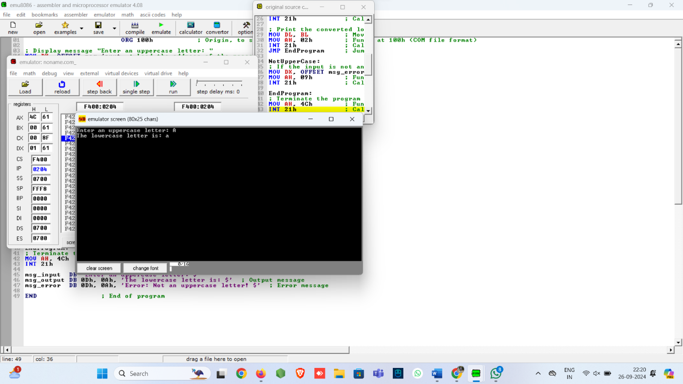

2. (a) Write a program in assembly language to print multiple characters on screen.

ORG 100h

MOV DX, OFFSET msg

MOV AH, 09h

INT 21h

MOV SI, OFFSET input_buffer

ReadCharacters:

MOV AH, 01h

INT 21h

CMP AL, 0Dh

JE DoneInput

MOV [SI], AL

INC SI

JMP ReadCharacters

DoneInput:

MOV BYTE PTR [SI], '$'

MOV DX, OFFSET msg_output

MOV AH, 09h

INT 21h

MOV DX, OFFSET input_buffer

MOV AH, 09h

INT 21h

MOV AH, 4Ch

INT 21h

msg DB 'Enter characters: $'

msg_output DB 0Dh, 0Ah, 'You entered: $'

input_buffer DB 50 DUP('$')

END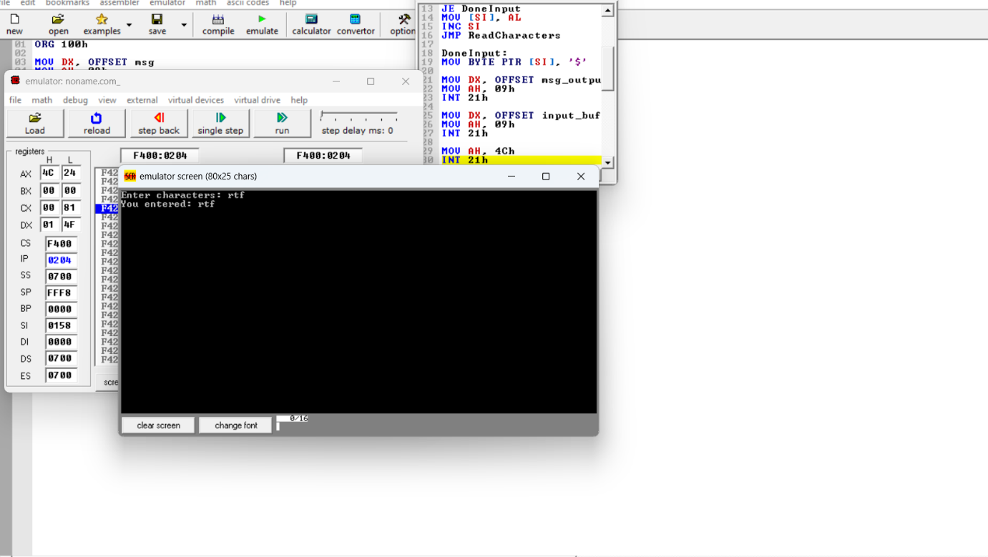

(b) Write an assembly language program to convert a lower-case letter to the

corresponding upper-case letter.

CODE:

ORG 100h

MOV DX, OFFSET msg_input

MOV AH, 09h

INT 21h

MOV AH, 01h

INT 21h

MOV BL, AL

CMP BL, 'a'

JL NotLowerCase

CMP BL, 'z'

JG NotLowerCase

SUB BL, 20h

MOV DX, OFFSET msg_output

MOV AH, 09h

INT 21h

MOV DL, BL

MOV AH, 02h

INT 21h

JMP EndProgram

NotLowerCase:

MOV DX, OFFSET msg_error

MOV AH, 09h

INT 21h

EndProgram:

MOV AH, 4Ch

INT 21h

msg_input DB 'Enter a lowercase letter: $'

msg_output DB 0Dh, 0Ah, 'The uppercase letter is: $'

msg_error DB 0Dh, 0Ah, 'Error: Not a lowercase letter! $'

END